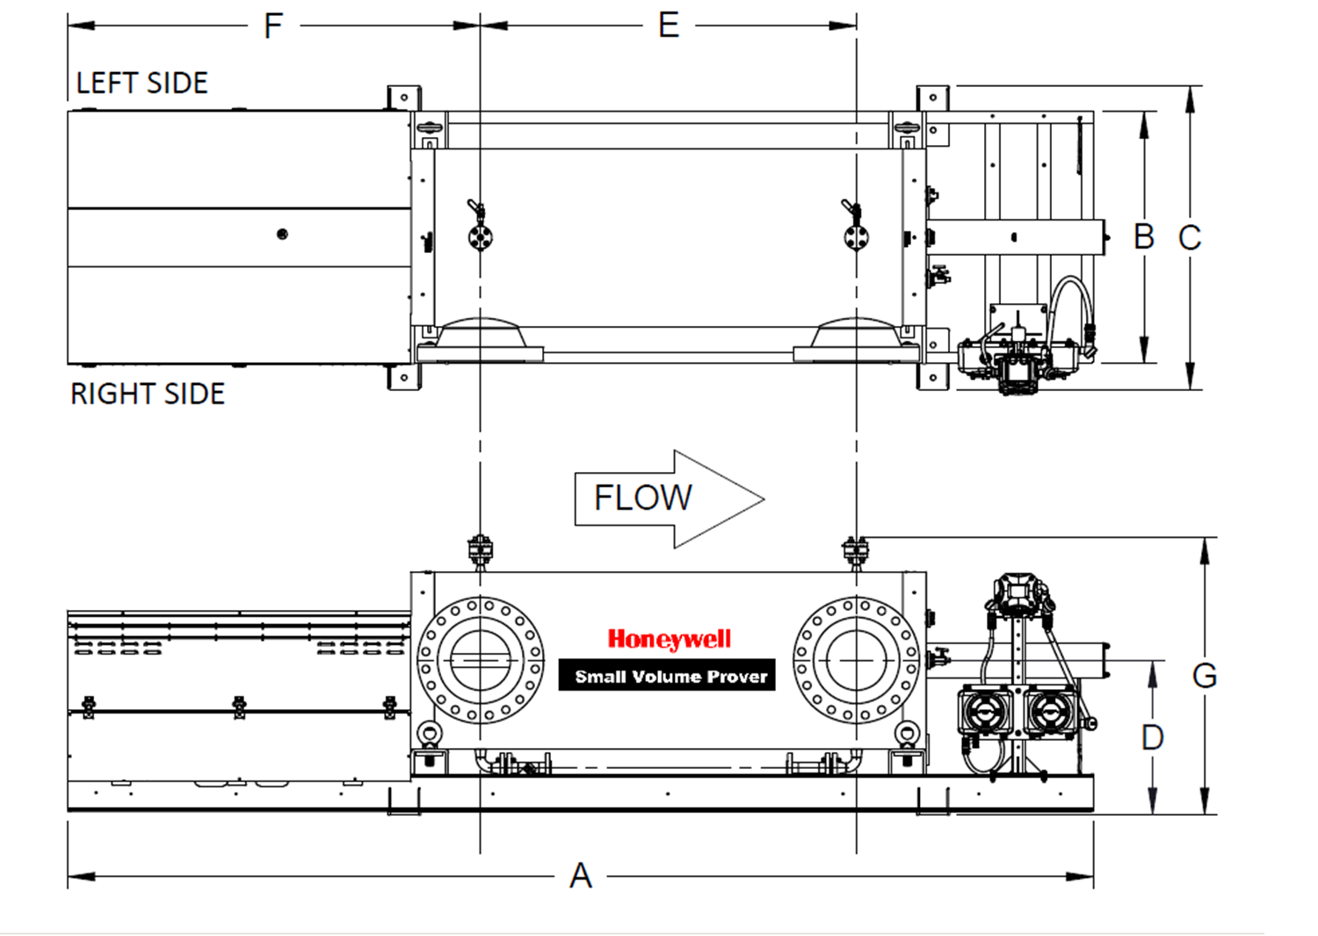

Introduction
Customers and channels shall use this document when filling in their RFQ for a small volume prover (SVP)

Customer Name: ODS Metering Systems

Date:

Project Name:

Quote Number:

Example : inlet and outlet flanges facing right, controller at right side facing right (default)

Type of Flowmeters used (check which apply)
type | check | Maker if known | Min flow rate | Max flow rate | Normal flow rate
Turbine
PD meter
Coriolis
Ultrasonic
Flow rate unit: BBL/H USGPM L/min m³/h

Process and Design temperature (contact the sales office if lower than -40 °C (-40 °F) or higher than 80 °C (176 °F)
Operating (Process) Temperature | Range: Min Max Normal | °F | °C
Design temperature | Range: Min Max | °F | °C

Process and design Pressures
Operating Pressure Range:  Design Pressure Range: | Range: Min Max Normal  Range: Min Max | psig | kPa | bar
Note: For Design temperatures above 37.8°C (100°F), pressure must be de-rated, following pressure standard ANSI B16.5

Process Viscosity Data: (Contact Sales Office for products above 100 cSt)
Viscosity at max/min operating temperature: | Density [kg/m³]: | Flow rate

Calibration reference data:
Reference Temperature for Prover Calibration: 60 °F 15 °C 20 °C Other:
Units for Prover Calibration and transmitters: °C, bar °C, kPa °F, psi

1.0 Model and maximum flow rate (choose one)
SVP Model |  | Max flowrate (PD and Turbine meters) |  |  | Max flowrate (Coriolis & US meters) Note 1
 |  | BBL/h | USGPM | m³/h | BBL/h | USGPM | m³/h
SVP005 |  | 715 | 500 | 114 | 390 | 273 | 62
SVP015 |  | 2140 | 1498 | 340 | 1560 | 1092 | 248
SVP025 |  | 3570 | 2499 | 568 | 1560 | 1092 | 248
SVP035 |  | 5000 | 3500 | 795 | 1950 | 1365 | 310
SVP050 |  | 7200 | 5040 | 1145 | 3113 | 2179 | 495
SVP085 |  | 12500 | 8750 | 1987 | 5843 | 4090 | 929
SVP120 |  | 17500 | 12249 | 2782 | 9353 | 6545 | 1487

Note 1: For coriolis and ultrasonic flow meters the flowmeter vendors recommend a minimum pass time of more than 1 sec. This effectively reduces the capacity of Small Volume Provers if one pass=one run is used, if multiple passes per run is used, the max flowrate remains as for turbine and PD meters.

1.1 Type of installation and material (choose one) | Process fluid wetted parts AISI 304/304L | Process fluid wetted parts AISI 316/316L
Standard prover for onshore installation
Portable prover with trailer supplied
Offshore prover: 316 Stainless Steel for wetted parts and for drive end mechanical components (chains, bars, sprockets etc)
Portable with Offshore combination

1.2 ASME/ANSI B16.5 Flange Rating (choose one) |  | 005 | 015 | 025 | 035 | 050 | 085 | 120
1A | Class 150 RF connection flanges |  | Y | Y | Y | Y | Y | Y
2B | Class 300 RF connection flanges |  | Y | Y | Y | Y | Y | Y
3C | Class 600 RF connection flanges | Y |  | Y | Y | Y | Y | Y
4D | Class 900 RF connection flanges | Y |  | Y | Y | Y | Y
6A | Class 150 RJ connection flanges |  | Y | Y | Y | Y | Y | Y
7B | Class 300 RJ connection flanges |  | Y | Y | Y | Y | Y | Y
8C | Class 600 RJ connection flanges | Y |  | Y | Y | Y | Y | Y
5D | Class 900 RJ connection flanges | Y |  | Y | Y | Y | Y

1.3 Inlet/outlet orientation (choose one)

01 | Inlet and outlet flange opposite - inlet right side
02 | Inlet and outlet flange same side - right side
03 | Inlet and outlet flange 90°, inlet on right side and outlet on top
04 | Inlet and outlet flange same side - left side
06 | Inlet and outlet flange both on top
07 | Inlet and outlet flange opposite - inlet left side
09 | Inlet flange on top & outlet on left
11 | Inlet flange on top and outlet on right
12 | Inlet flange on left and outlet flange on top

1.4 Safety ratings in Hazardous Areas and motor voltage (choose one)
CSA | 005 | 015 | 025 | 035 | 050 | 085 | 120
24 VDC
120 VAC 60 Hz | * | * | * | * | *
220 VAC 60 Hz | * | * | * | * | *
220/240 VAC, 60 Hz, 3 phase
460/480 VAC, 60 Hz, 3 phase
Standard : Available -20°C to +40°C (-4°F to +104°F) or -40°C to +40°C (-40°F to +104°F) *Only available from -20°C to +40°C (-4°F to +104°F)

ATEX or IECEx(Note-1) | 005 | 015 | 025 | 035 | 050 | 085 | 120
24 VDC | ** | ** | ** | **
220 VAC, 50 Hz
220/240 VAC, 50 Hz, 3 Ph | *** | *** | *** | *** | *** | ***
380/400/415 VAC, 50 Hz, 3 Ph
460/480 VAC, 60 Hz, 3 Ph
690 VAC, 60 Hz, 3 Ph
Standard : Available -20 °C to +40°C (-4°F to +104°F) or -40°C to +40°C (-40°F to +104°F) or -20°C to +60°C **Only ATEX, no IECEx available ***Only available -20°C to +40°C (-4°F to +104°F) or -20°C to +60°C (-4°F to +140°F) ;
For other combinations of Voltages, Frequencies and Approvals, please contact the Honeywell sales office.
Note-1, sub assembly level certificates are provided
.

1.5 & 2.1 Safety ratings in Hazardous Areas and ambient temperature ranges (Choose one)
CSA/US Class I, Div.1, Group D T2C* | -20 °C to +40 °C | -40 °C to +40 °C
CSA/US Class I, Div.1, Group C T3B* | -20 °C to +40 °C | -40 °C to +40 °C
ATEX II 2 (1) G Ex d [ia Ga] IIB T4 (T3) Gb, II 2 G c IIB T4 (T3) | -20 °C to +40 °C | -40°C to +40 °C | -20 °C to +60 °C
IECEx (Note-1) | -20 °C to +40°C | -40 °C to +40 °C | -20 °C to +60 °C
*Not available on offshore provers
Note-1, available on the components level IECEx certificate.

1.6 Flow tube finish (choose one)
Standard, Stainless steel brushed
White paint (single coat)
Other paint on request (please specify; YYY option table 6 to be completed)

3.1 Water draw / Calibration (choose one)
Standard, Gravimetric water draw according to API MPMS 4.9.4
Volumetric water Draw according to API MPMS 4.9.2

3.2 Nitrogen purging of drive end for cold products, -40°C to -10°C (-40°F to +14°F) (choose one)
Standard, Without Nitrogen purge system
Nitrogen purge system, Automatic (not available below ‐20 °C ambient temperature)
Nitrogen purge system, Manual

3.3 Insulation (choose one)
Standard, Without insulation
Insulation plate
Insulation jacket and plate

4.1 NACE requirement (choose one)
Standard, No NACE
NACE MR-0175 (ISO 15156) for H2S containing applications

4.2 Material of seals (choose one)
Standard Ekonol® filled PTFE seal
Carbon Fiber Reinforced PTFE seal (crude oil)

4.3 Location and Power of Controller (choose one)
AC voltage (With AC/DC converter) Right side facing right (check the drawing on top of this document)
AC voltage (With AC/DC converter) Left side facing left
24 VDC power supply; Right side facing right (check the drawing on top of this document)
24 VDC power supply; Left side facing left

5.1 Pressure and Temperature transmitters (choose one)
Standard, Honeywell Transmitters (Models; ST700 and STT750)
Rosemount Transmitters (Models; 3051T and 3144P)
Other transmitters (please specify, YYY option table 6 to be completed)
No transmitters

5.2 PED Approval (choose one)
Standard, No approval
PED (Pressure Equipment Directive, EU requirement)

5.3 PMI (Positive Material Identification) (choose one)
Standard, No PMI
PMI (X-ray Fluorescence) on welds and pressurized parts

6 Other Comments/requirements (incl. special YYY requirements here):

7 Crating (choose one)
No Packing/ crating
Standard, Sea-worthy Wooden Crate
Blocking & Securing in Sea-going Container (when not possible to be crated, i.e., on trailer: container to be provided by client)
Other: (please specify, YYY option: table 6 to be completed)

8 Other Options (choose all which apply)
Battery pack/power supply unit (only possible for use with 24 VDC motor and controller)
Leak detection instrumentation consists of a precision differential pressure gauge and SS hoses
Water Draw Kit; Power supply, cables, and solenoid valve assembly.
Water Draw Instrumentation Kit: high accuracy thermometers and pressure gauge (NIST traceable).
Set of spare parts, 2 years (complete seals kit, set of optical switches, motor stop switch, motor relay).
Commissioning: Onsite start-up/commissioning by Honeywell Enraf service technician and/or authorized service provider
Saudi Aramco compliant version
Det Norske Veritas Offshore compliant version
Bureau Veritas Marine Offshore compliant version

Other information
Product name or Type of Process Fluid: (Please supply relevant Material Safety Data Sheet)

Brand of Proving Computer used at site.
OMNI | ABB/Spirit | Daniel/Emerson | Krohne | Dynamic | Virtual | Other

Name Plate and Tag name Information:
Customer name to be displayed on Name Plates: | No / Yes;
Process fluid to be displayed on Name Plates: | No / Yes;
Tag Number for Motor:
Tag Number for Pressure Transmitter:
Tag Number for Thermowell:
Tag Number for Temperature Transmitters: | Switch Bar Temp Transmitter: | Prover Temp Transmitter:

Standard Prover Documentation
Document | Document Schedule
Drawings (Outline, frame mounting, service clearance, wiring) | Two (2) weeks AAO *
FAT procedure | Two (2) weeks AAO *
Inspection and Test Plan | Two (2) weeks AAO *
Honeywell Enraf SVP Operation and Service Manual | Two (2) weeks after shipment
Hydrostatic Pressure Test Certificate | Two (2) weeks after shipment
Dielectric Strength Test Certificate | Two (2) weeks after shipment
Flow Tube Material Certificate | Two (2) weeks after shipment
Major Wetted Parts Material Certificates | Two (2) weeks after shipment
Hazardous Electrical Component Certificate | Two (2) weeks after shipment
Instrument Calibration Certificates (Includes weights,  thermometers, PI-tape, pressure gauge, ID micro meter,  transmitters and ground bond testing) | Two (2) weeks after shipment
Instrument Calibration Certificates for temperature and pressure instruments (if supplied with the SVP) | Two (2) weeks after shipment
Transmitter Manuals (if supplied with the SVP) | Two (2) weeks after shipment
Welder Qualifications | Two (2) weeks after shipment
Welding Procedures | Two (2) weeks AAO *
*AAO is After Acceptance of Order by Honeywell Engineering and Honeywell Order Management

Distributor and/or Customer Information:
Sales Contact: |  | Phone: |  | Fax: |  |  | Email:
Technical Contact: |  | Phone: |  | Fax: |  |  | Email:
Project Manager: |  | Phone: |  | Fax: |  |  | Email:
End User: |  |  | End User Location (Country):

Distributor/
Customer Signature: ____________________________ Date: ________________________

